Random Number Generation Python and Linux

David Graves
Colorado State University Global
CSC507
Dr. Joseph Issa
July 27, 2025

Generating Random Numbers in Python
The following exercise was performed to understand how one might increase the speed of both a Linux script and Python program, both designed to produce a list with 1,000,000 lines of random numbers and write the result to a new .txt file. I used the initial code from both instances, created during the first Portfolio milestone, and updated them to include 1,000,000 lines instead of 1,000 lines. In Linux I leveraged the ‘$Seconds’ variable and imported ‘date time’ for Python to record time to execution to measure against as a base line. The following Image 1 shows the Linux results and Image 2 shows the Python time to execute the first run.
Image 1 (Linux – number.sh) – 36.00 seconds to execute
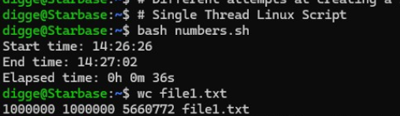
Image 2 (Python – random_number.py) – 1.32 seconds to execute
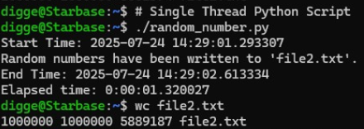
These initial results both produced similar files but took considerably different times to execute. I believe the main reason for this difference is that I used an optimized library ‘random’ in Python whereas the Linux script as a command line processor has not been optimized for specific tasks like generating a set of random numbers. With that in mind I’ve performed a couple different experiments across both Linux and Python to see if I could improve on the results in both cases.
Multithreading and Parallelism
The first set of experiments that I executed involved creating a new Python program including the “threading” library and associated line functions. Multithreading makes sense to try since it allows threads to run concurrently which can help split up the work required. Linux does not offer the ability to “multithread”, but since I have multiple processors, I was able to split the work up between all four of them and combine them via Parallelism which is in essence multithreading. The following Image 3 shows the Linux results and Image 4 shows the Python time to execute.
Image 3 (Linux – numbers1.sh) – 4 seconds to execute
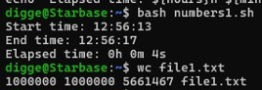
Image 4 (Python – random_number1.py) – 1.29 seconds to execute
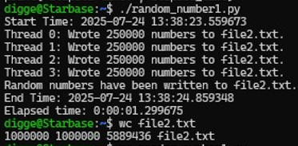
By splitting the job up across all available CPUs and executing the tasks simultaneously with the updated Linux script I was able to reduce the time to completion from 36.00 seconds down to 4 seconds. This similar approach in Python yielded about the same results using multithreading vs just running the standard python program using the ‘random’ library. I believe this is because the Global Interpreter Lock within Python allows only one thread to execute even with my multi-core processor so there was not really any advantage there.
Multiprocessing
Another thought I used to try and speed things up was to use multiprocessing. Multiprocessing can take advantage of executing multiple processes across multiple cores where possible. I’ve roughly done that in Linux using Parallelism but wanted to see what it looked like in Python. I leveraged the “multiprocessing” library with the appropriate in line functions to run the same experiment in Python. This resulted in the following shown in Image 5 below.
Image 5 (Python – random_number3.py) – 4.48 seconds to execute.
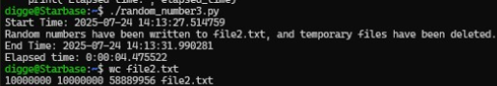
This one surprised me in that I would have thought that it may have outperformed or at least maintained similar performance to the other 2 Python attempts, but it came in quite a bit slower at 4.48 seconds. I believe this is because each process here requires a separate OS-level process which creates additional overhead compared to threads, which share the same memory space. It might also be slower because the task I was asking it to perform is I/O bound, such as writing to a file and multiprocessing usually performs better with CPU bound tasks.
Reflection
In conclusion, the best method I’ve found to produce and write a random list of 1,000,000 numbers to a .txt file in Python is to use the ‘random’ library and save the code space by not attempting to multithread or multi-process. Using the multiprocessing approach in Python produced less optimal time to execution and required quite a bit more complex code to get the intended result. While using multithreading in Python produced minimal time savings of .06 seconds and increasing code complexity of 36 lines as shown below in Image 6. This small performance increase doesn’t warrant the additional overhead in code complexity.
Image 6 (Python std – random_number.py vs. Multithread – random_number1.py)
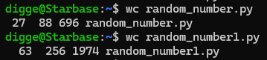
Whereas, with Linux using Parallelism, I was able to take advantage of the multiple processing power of my laptop to greatly reduce the time to execution. In this instance I believe the increase in code complexity and effort are warranted considering the reduced time to execution. I’ve included the ‘wc’ view for both Linux scripts below in Image 7 for reference below.
Image 7 (Linux std – numbers.sh vs. Parallel – numbers1.sh)
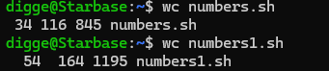
After reviewing the results and thinking through why they performed the way they did I don’t believe that increasing my current processing power would make a meaningful difference with the Python program, but I can see where that could help with the Linux script. By splitting the job up four ways and leveraging more processing power it decreased the time by 32 seconds, bringing it closer in performance to the Python program that I started with. This stands to reason that with additional computing power the Parallel method in Linux may reach and surpass the same performance as Python ultimately.

